Automatic synchronization from Gitee repository to GitHub repository through synchronization script

Create a repository on gitee huaweiRep.git
configure gitee webhooks for repository huaweiRep.git
webhooks url http://139.159.144.99:8080/synGit


Create a repository on github huaweiRep.git
github repository url , git@github.com:xiaxueqiu/huaweiRep.git

Configure SSH keys for github
Generate a key pair in the synchronization script server through “ssh-keygen”, copy the public key to GitHub, configure SSH keys, push the code to gitee, and automatically complete the synchronization from gitee repository to GitHub repository through the server synchronization script program;

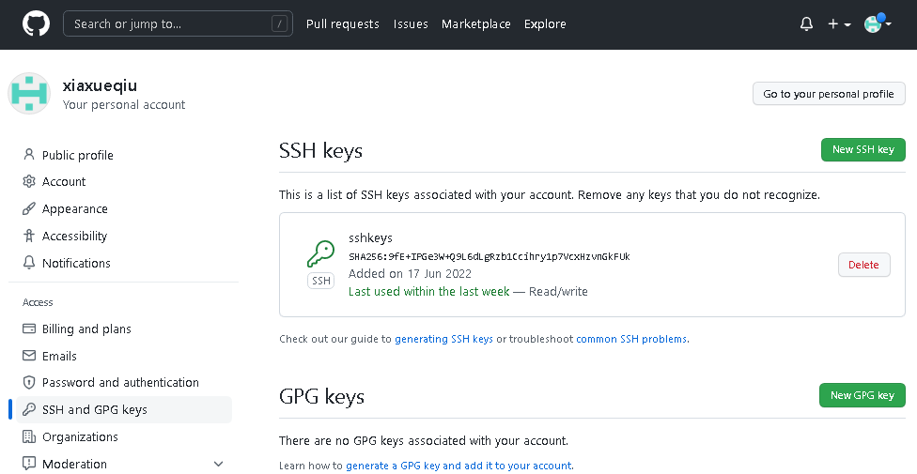

git clone repository to local ，git push to gitee
git clone https://gitee.com/xia-xueqiu/huaweiRep.git，
new file syn_gitee_to_github.txt，Write the content，
execute the git command and submit it to the gitee code repository:

git add .
git commit -m "first commit"
git remote add origin https://gitee.com/xia-xueqiu/huaweiRep.git
git push -u origin master

Results gitee to GitHub automatic synchronization was realized.
Gitee above is the result of code submission:

The huaweiRep repository of GitHub automatically synchronizes the huaweiRep repository code of gitee:
